Personal Wellness Plan

Full Name:

I prefer to be called:

DOB:

Name:

The person who knows me best is:

Words I Would Use to Describe Myself

My Strengths

My Life So Far…

Interests and Hobbies

Education:

Occupation:

Places I Have Lived

Significant People in My Life:

Significant Events, Dates, and Experiences:

DOB:

Name:

What Else You Should Know About Me

Things That Make Me Happy or Help Me Relax:

Ways I Show I Care About Others:

Personal Belongings I Keep Nearby:

Ways You Can Help If I Seem Upset or Distressed:

Things That Upset Me or Make Me Feel Anxious:

Spiritual/Cultural Beliefs and Practices:

Ways I Show I’m In Pain or Distressed:

My Daily Routines

**Communication, Hearing, and Vision:**

DOB:

Name:

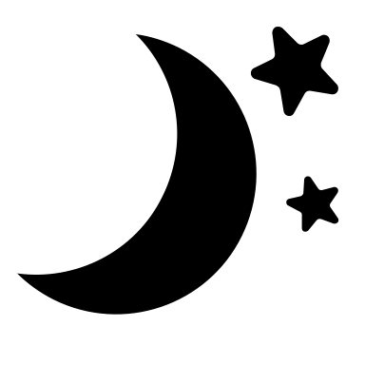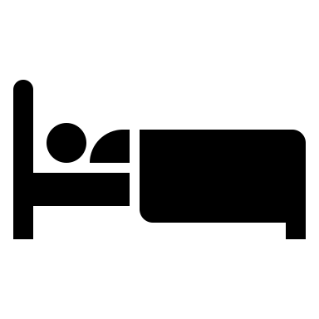

**Sleep and Rest Routines**

**Mornings:**

**Afternoons:**

**Evening/Nighttime:**

**Sleep Issues:**

(e.g., getting around/mobility needs, cooking/meal prep, etc.)

(e.g., things I like to do by myself, things I need help with; when getting washed or dressed, you may assist me by…; list any preferences with personal care)

(e.g., How do you prefer to communicate? What’s the best way to communicate with you? Communication/hearing/vision devices or aides? Extra time/support needed?)

**How You Can Help with Basic Safety:**

**Maintaining My Independence:**

My Daily Routines (continued)

**Food and Drink**

DOB:

Name:

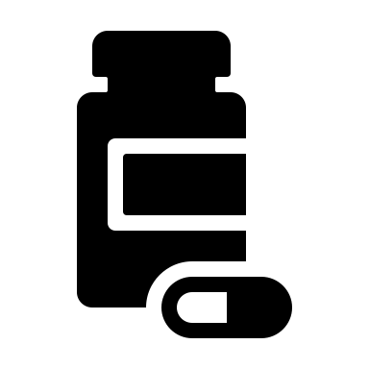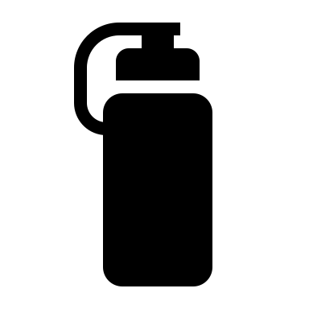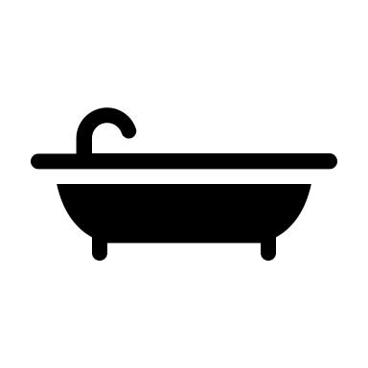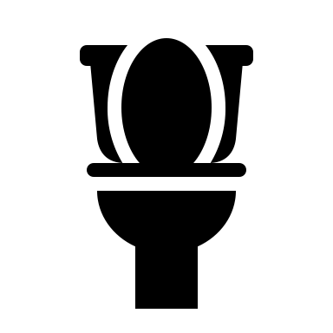

How I Like to Take My Medication:

I may need help with:

Bathroom Routines/Schedule:

I may need help with:

My Favorite Food or Drinks:

I do NOT like:

Dietary considerations: (e.g., allergies, special diet, choking concerns)

When eating/drinking or preparing meals you may help by:

**Bathroom and Personal Care**

**Medications**

**Other Things You Should Know:**